**1**. **What application layer protocol is commonly used to support for file transfers between a client and a server**?  
HTML  
HTTP  
FTP  
Telnet

**2**. **What are two forms of application layer software? (Choose two.)**  
applications  
dialogs  
requests  
services  
syntax

**3**. **A network administrator is designing a network for a new branch office of twenty-five users. What are the advantages of using a client-server model? (Choose two.)**  
centralized administration  
does not require specialized software  
security is easier to enforce  
lower cost implementation  
provides a single point of failure

**4**. **What is the purpose of resource records in DNS?**  
**temporarily holds resolved entries**  
used by the server to resolve names  
sent by the client to during a query  
passes authentication information between the server and client

**5**. **What is the automated service that matches resource names with the required IP address?**  
HTTP  
SSH  
FQDN  
DNS  
Telnet  
SMTP

**6**. **What three protocols operate at the Application layer of the OSI model? (Choose three.)**  
ARP  
DNS  
PPP  
SMTP  
POP  
ICMP

**7**. **What are three properties of peer-to-peer applications? (Choose three.)**  
acts as both a client and server within the same communication.  
requires centralized account administration.  
hybrid mode includes a centralized directory of files.  
can be used in client-server networks.  
requires a direct physical connection between devices.  
centralized authentication is required.

**8**. **Which application layer protocols correctly match a corresponding function? (Choose two.)**  
DNS dynamically allocates IP addresses to hosts  
HTTP transfers data from a web server to a client  
POP delivers email from the client to the server email server  
SMTP supports file sharing  
Telnet provides a virtual connection for remote access

**9**. **Which email components are used to forward mail between servers? (Choose two.)**  
MDA  
IMAP  
MTA  
POP  
SMTP  
MUA

**10**. **As compared to SSH, what is the primary disadvantage of telnet?**  
not widely available  
does not support encryption  
consumes more network bandwidth  
does not support authentication

**11**. **Which statements are correct concerning the role of the MTA in handling email? (Choose three.)**  
routes email to the MDA on other servers  
receives email from the client’s MUA  
receives email via the POP3 protocol  
passes email to the MDA for final delivery  
uses SMTP to route email between servers  
delivers email to clients via the POP3 protocol

**12**. **Which two protocols are used to control the transfer of web resources from a web server to a client browser? (Choose two.)**  
ASP  
FTP  
HTML  
HTTP  
HTTPS  
IP

**13**. **A small home network has been installed to interconnect three computers together for gaming and file sharing. What two properties represent this network type? (Choose two.)**  
User accounts are centralized.  
Security is difficult to enforce.  
Specialized operating system software is required.  
File permissions are controlled by a single computer.  
A computer that responds to a file sharing request is functioning as a server.

**14**. **Which layer of the OSI model supplies services that allow user to interface with the network?**  
physical  
session  
network  
presentation  
application  
transport

**15**.

[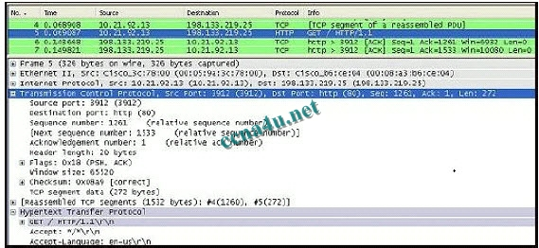](http://answers.ccna4u.net/wp-content/uploads/2011/01/151.jpg)

ccna 1 chapter 3 answers 100%

**Refer to the exhibit. What is the destination port for the communication that is represented on line 5?**  
80  
1261  
15533  
3912  
65520

**16**. **What are two characteristics of peer-to-peer networks? (Choose two.)**  
scalable  
one way data flow  
decentralized resources  
centralized user accounts  
resource sharing without a dedicated server

**17**. **What application layer protocol describes the services that are used for file sharing in Microsoft networks?**  
DHCP  
DNS  
SMB  
SMTP  
Telnet

**18**. **What are two characteristics of clients in data networks? (Choose two.)**  
use daemons  
initiate data exchanges  
are repositories of data  
may upload data to servers  
listen for requests from servers

**19**. **What is the role of the OSI application layer?**  
provides segmentation of data  
provides encryption and conversion of data  
provides the interface between the applications on either end of the network  
provides control of all the data flowing between the source and destination devices

**20**. **How does the application layer on a server usually process multiple client request for services?**  
ceases all connections to the service  
denies multiple connections to a single daemon  
suspends the current connection to allow the new connection  
uses support from lower layer functions to distinguish between connections to the service